**Project Plan**

*JUGO*



| **Date : 28/11/2022** |
| --- |
| **Version : v1.1** |
| **State : In progress** |
| **Author : Kaan & Cas** |

#### Version history

| **Version** | **Date** | **Author(s)** | **Changes** |
| --- | --- | --- | --- |
| v0.1 | 18/11/2022 | Kaan | Making a start on Project Assignment |
| v1.0 | 25/11/2022 | Kaan & Cas | Filling in everything that’s blank |
| v1.1 | 28/11/2022 | Kaan | Edit “Scope and preconditions”  Add “Case”  Rename “Goal of the project” to “Solution”  Edit “Strategy”  Edit “Finances and risk” |

Contents

1. Project assignment 4

1.1 Context 4

1.2 Goal of the project 4

1.3 Scope and preconditions 4

1.4 Strategy 4

1.5 Research questions 4

1.6 End products 4

2. Project Organisation 6

2.1 Stakeholders and team members 6

2.2 Communication 6

3. Activities and time plan 7

3.1 Phases of the project 7

3.2 Time plan and milestones 7

4. Testing strategy and configuration management 8

4.1 Testing strategy 8

4.2 Test environment and required resources 8

4.3 Configuration management 8

5. Finances and Risk 9

5.1 Project budget 9

5.2 Risk and mitigation 9

# Project assignment

## Case

JUGO wants the best way to drive to customers without any traffic jams. JUGO sends employees to their customers for meetings with the client. Often JUGO’s employees are stuck in traffic jams when they are on the road to the client and turn up late. The largest clients are ASML which is settled in Eindhoven, Phillips which is also settled in Eindhoven, Alliander which is settled in Arnhem and Post NL which is settled in Den Haag.

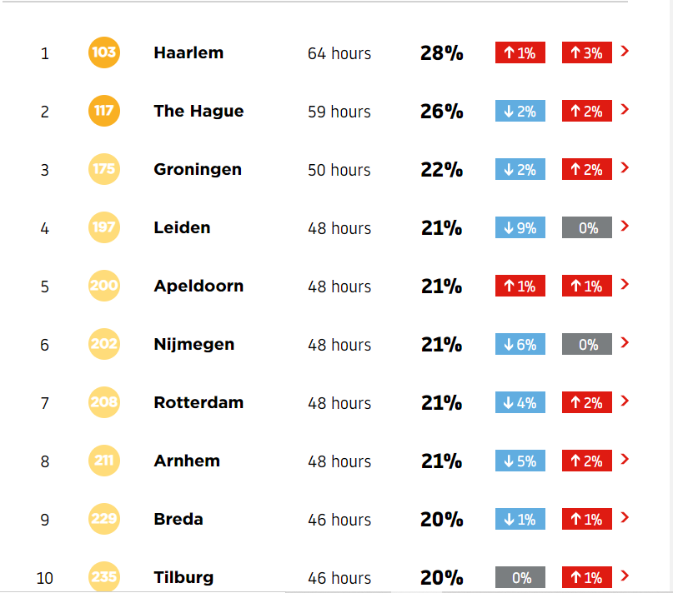

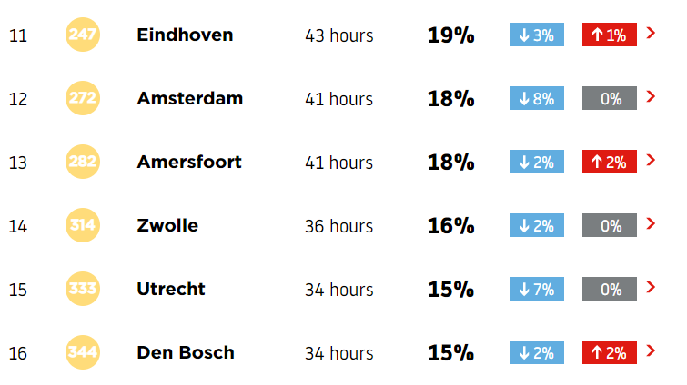

So if you look at the pictures above, you can see that in Eindhoven 43 hours of traffic jams occur per year. Because the biggest client of JUGO is in Eindhoven, the employees often get stuck in traffic jams. This is what JUGO wants to prevent.

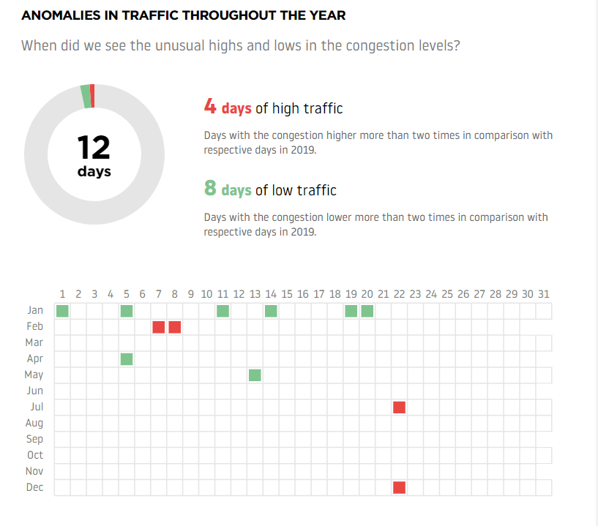

There are eight days of low traffic in Eindhoven, these days are the best days for JUGO to send their employees to Eindhoven. On the four days of high traffic is it best to not send employees to Eindhoven, because on those days it has the most chance to form a traffic jam.

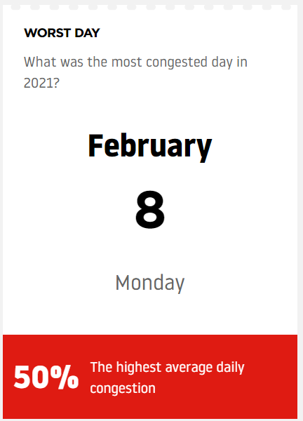

According to TOMTOM, february 8 2021 is the worst day in traffic. On this day there were the most traffic jams in Eindhoven in 2021.

## Solution

Our solution is to generate data visualisations about when there are traffic jams. If we get this finished early. We would like to expand it into a program where you can actually input from where to where you are travelling.

## Scope and preconditions

| **Inside scope:** | **Outside scope:** |
| --- | --- |
| Generate data visualisations | A website |
| Predict traffic jam locations | - |
| Predict traffic jam durations | - |
| Make use of static ANWB data | - |
| The area we predict in is, an imaginary line between The Hague and Haarlem, everything below that line. | The area above the imaginary line |

One of our preconditions is that we need any kind of data. JUGO provided ANWB traffic jam data. Using this data we will train a model to predict where there will be traffic jams and for how long. We want to deliver this in a form of data visualisations, think of a graph.

## Strategy

We don’t use a certain strategy. But the strategy our way of working resembles the most is the waterfall methodology, since we have a backlog with activities that have to get done and we just pick an activity and work on it. If we approach a meeting with the stakeholders, we set a goal for ourselves like: “This really needs to be done before the meeting”.

## Research questions and methodology

Main question: *If you have to travel and there is a traffic jam, which route is the best to take and how long will the traffic jam last?*

Sub questions:

* *What traffic prediction programs do already exist?*
* *What are the contributing features?*
* *What requirements are needed for the dataset?*
* *What machine learning algorithm gives the best results?*

## End products

For now we just want to deliver data visualisations as an end product. If this gets done early we want to deliver a program where you can fill in start and end point yourself.

# Project organisation

## Stakeholders and team members

| **Name** | **Abbreviation** | **Role and functions** | **Availability** |
| --- | --- | --- | --- |
| *Ronald van Lent* | *RL* | *Project owner* | *Days of delivery* |
| *Kaan Gögcay* | *KG* | *Group leader* | *Monday-friday 9:00-16:00* |
| *Nick Friendship* | *NF* | *Assistant group leader* | *Monday-friday 9:00-16:00* |
| *Sten Rens* | *SR* | *Secretary* | *Monday-friday 9:00-16:00* |
| *Cas Esselink* | *CE* | *Notary* | *Monday-friday 9:00-16:00* |

## Communication

There is email communication between our secretary Sten and the project owner Ronald. Between the group members and the teachers, the communication goes via teams. The communication within the group is done in whatsapp. This covers online communication. Further we have offline communication at school.

# Activities and time plan

## Phases of the project

In our project we don’t have a main phase. For our project we make use of the AI project methodology provided by Fontys.

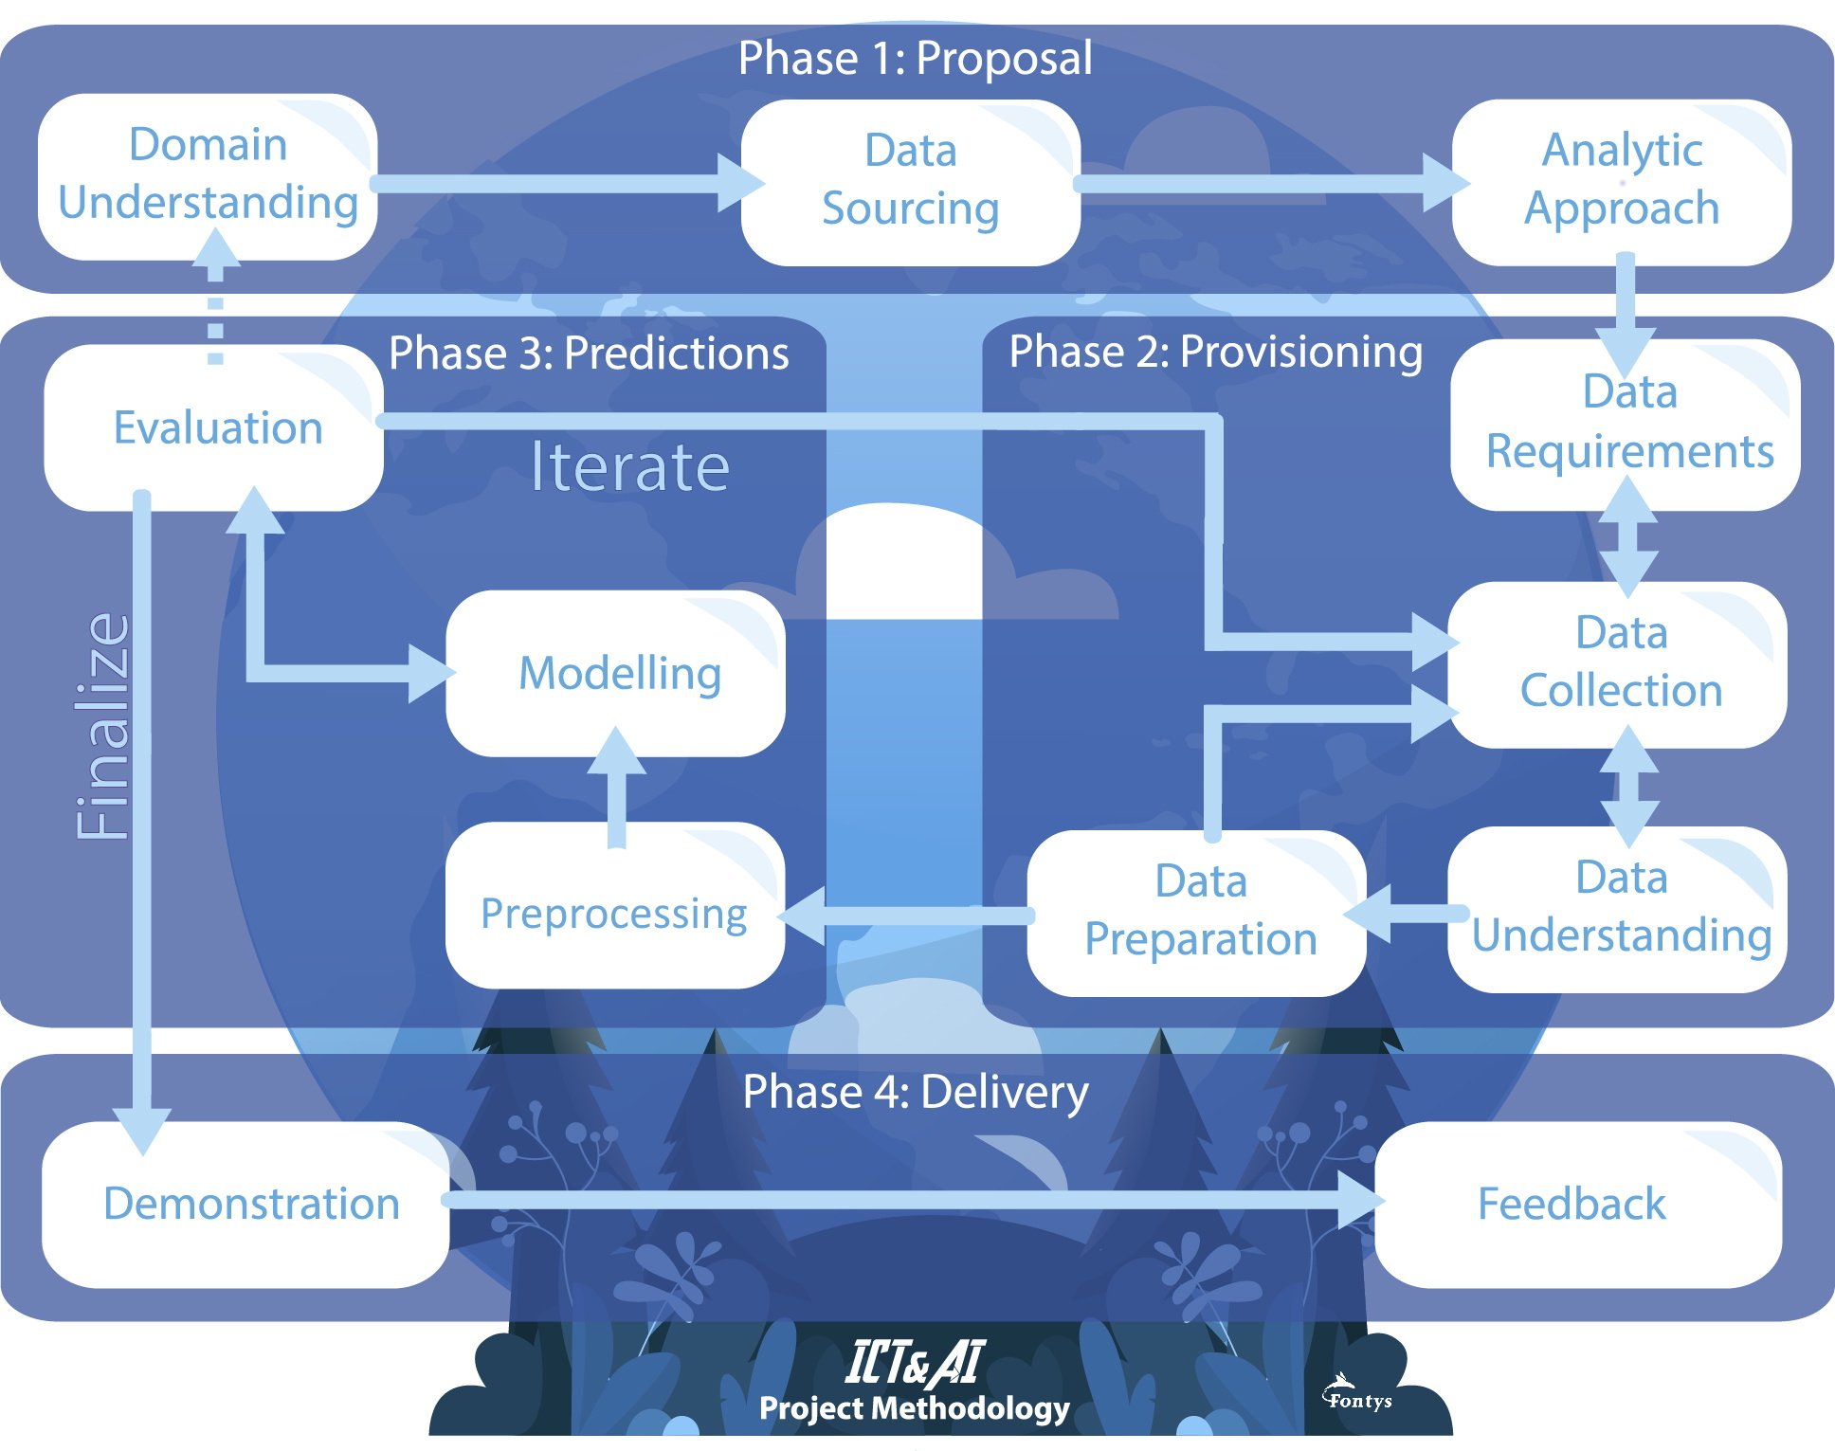

## Time plan and milestones

| **Phasing** | **Effort** | **Start date** | **Finish date** |
| --- | --- | --- | --- |
| Phase 1: Proposal |  | 9/10/2022 | 30/10/2022 |
| Phase 2: Provisioning (first iteration) |  | 30/10/2022 | 30/11/2022 |
| Phase 3: Predictions (first iteration) |  | 30/11/2022 | ../../2022 |

# Finances and risk

In this table you can see A risk, the preventive action for the risk and the mitigation action for if it actually happens.

| **Risk** | **Prevention activities** | **Mitigation activities** |
| --- | --- | --- |
| Group members don't contribute enough. | Good task distribution and communication. | Talk about as soon as possible, when this happens. |
| Group members quit. | - | Quickly redistributes the tasks. |
| Group members arrive late. | Have agreements and penalties on lateness. | Uphold the agreements. |
| Group members don’t show up. | Have agreements and penalties on absence. | Uphold the agreements. |
| Code isn’t understandable for colleagues. | Discuss coding conventions. | Refactor existing code. |

# Sources

*Eindhoven traffic report*. (n.d.). TomTom Traffic Index. https://www.tomtom.com/traffic-index/eindhoven-traffic/